INITIAL

TRAUMA HEALING EQUIPPING SESSION

Bible-based Trauma Healing

About the Program Model

This proven model of the Trauma Healing Institute uses applied Scripture and mental health principles to address spiritual and emotional wounds caused by trauma of war, violence, natural disasters, and abuse. The book Healing the Wounds of Trauma: How the Church Can Help has been translated and taught in over 100 countries with more than 194 language groups in Africa, Asia, the Pacific and the Americas.

About the Session

At this initial equipping session, participants learn basic biblical and mental health principles related to trauma care; explore if they themselves are carrying any wounds of trauma or loss and bring those to Christ for healing; learn how to lead groups in a participatory way; learn the program model; and develop plans for using what they have learned in their community.
Trauma healing facilitators aim to “do no harm” to those they help. To this end, participants are evaluated during the equipping session. A simple test measures mastery of content. A short practice facilitation exercise includes feedback on facilitator strengths and suggestions to address areas needing improvement.
This initial equipping session is followed by a few months of practicum in which apprentice facilitators teach at least the core lessons at least two times. The training process is completed with an advanced equipping session.

Who should attend?

This session is open to laypeople and clergy, mental health professionals, social justice advocates, NGO workers, and others who would like to explore becoming a trauma healing facilitator so that they can provide basic care for those wounded by trauma or loss and optionally train others to do so.

Necessary qualifications:

- Able to communicate in English. | - At least 18 years old.
- Have sufficient status to teach | - Committed to help trauma survivors.
others in a community. | - Able to give at least 2 weeks per
- Able to attend the entire session. | year to trauma healing.
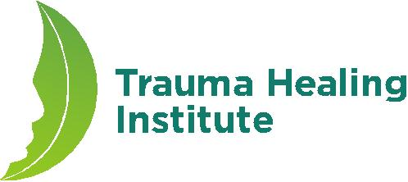

28 June-1 July
2018

Thursday evening 6:00-9:00pm
Friday-Saturday 8:00am-5:00pm
Sunday afternoon 1:00-5:30pm

Decatur, IL

Northwest Christian Church
1306 N Stanley Dr
Decatur, IL 62526

Sponsor

Northwest Christian Church

Contact

Shonna Ingram shonna.ingram@pbti.org

Registration

- $180 includes materials and snacks but not meals, housing, or travel.

- Register online at.

- Registration deadline:
Noon, 10 June 2018

